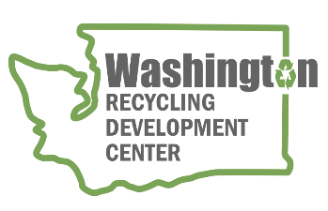
AGENDA
Recycling Development Center Advisory Board
Wednesday October 11, 2023 | 9 am to 12 pm (Pacific time)
Join us virtually, register for the remote meeting on Zoom

Meeting Overview  - Roundtable updates  - Presentations | Facilitator: Mya Keyzers  Zoom Host: Caleb Carlson  Notes: Tina Schaefer

Agenda – Strategic Planning

9:00 am Welcome
- Agenda review

9:05 am Board roundtable and Ecology/Commerce updates
    - Board member roundtable
    - Commerce & Ecology updates – Kara Steward
    - NextCycle updates – Tina Schaefer

9:25 am Board roundtable and Ecology/Commerce updates
    - Organics management presentation - Chery Sullivan
9:45 am Bio break
10:00 am Strategic Planning
    - Past, present, future presentation – Kara Steward
    - Priority ranking tool – Mya Keyzers
    - Project ideas by material type – Scott Morgan facilitating.
    - Brainstorming session
11:00 am Wrap-up
WE WILL HOLD QUARTERLY BOARD MEETINGS FOR 2023 ON THE 2nd WEDNESDAY OF THE MONTH, FROM 9 am to Noon, FOLLOWED BY A FACILITY TOUR. BOARD MEMBERS HAVE THE OPTION TO MEET IN-PERSON WITH INTERESTED PARTIES ATTENDING IN-PERSON OR VIA ZOOM. NEXT QUARTERLY MEETING WILL BE January 10th, 2024 (location to be determined).
For more information about the Recycling Development Center, visit the Advisory Board EZview website.
If you have questions, reach out to the Center team by email: RecDevCenter@ECY.WA.GOV
Please share this information. We welcome interested parties to sign up on the Recycling Development Center email list.

